**Introduction:**

Times where sources of entertainment were limited to technologies such as television and radio have been surpassed with the unlimited potential of the internet age. Today, the world is connected through different means of digital media and has ready access to resources required to explore the extent of the digital revolution. Social media applications and web portals have been found to be major sources of entertainment, education and information sharing. Social media has not only provided a platform for people to showcase their talents with a limited budget but has also generated opportunities for people to be major influencers to all demographics. YouTube is one of the dominant social media platforms that attracts billions of viewers per day all around the world. It is a video sharing platform that allows users to create and upload video blogs(vlogs) with different types of video content such music videos, podcasts, interviews, tv shows, lifestyle vlogs, travel vlogs, talent videos, movies and documentaries. With billions of viewers watching videos uploaded by their favorite content creators, YouTube artists are now considered to be major influencers for people of all age brackets, especially the younger age group. Consequently, these YouTube artists with such influence are now referred to as YouTube celebrities. The presence of such social media celebrities allows brands and marketers the opportunity to reach and target the right consumer market to increase their business value and outreach.

**Project Scope:**

The proposed project is based on a research study to analyze different aspects of the YouTube community such as:

* Type of influence YouTube content creators have on different age groups
* Type of content that attracts viewers and makes these YouTubers popular
* Identifying appropriate channels for brands and marketers to target demographic groups fit for their business needs.

**Resources:**

The data set to be used for the analysis consists of the following information:

* YouTube artists
* Top Channel, Channel content
* Demographics such as location, age groups and gender
* Views count, Subscriber count
* Number of uploads, users per day, Number of channels
* Number of paying subscribers
* Mobile application users
* Estimated revenue
* Number of likes and dislikes per videos
* Types and number of comments
* Brands collaborated

The data set can be updated with more statistics that provides new insights beneficial for the study.

The proposed tools to be used for the project includes MS Excel, R studio and MySQL.

**Objectives:**

* Identify resources and appropriate data sets required to achieve defined project scope
* Analyze and clean the data set used for better analysis and inferences
* Perform data mining to obtain valuable insights into the data
* Plot graphs and charts for statistical analysis of trends over the years and visualization of distribution of the sample data set
* Derive inferences and insights based on statistical analysis to address research questions

**Target Audience:**

* The research analysis can be used by various commercial and non-profit organizations to identify channels for advertisements and sales so that they could target the right audience and have a better outreach.
* The analysis of the trend in content creation in YouTube can provide valuable insights on the type of content that attracts different age groups and can help new artists in their production and the film industry to launch trending contents into the digital platform.
* The study also tries to analyze behavioral patterns of younger generation based on YouTube influence which can be used by various health and government organizations to encourage or limit the type of exposure to certain content produced on the digital platform.

**Timeline:**

The timeline to achieve various deliverables is represented using the following Gantt chart:

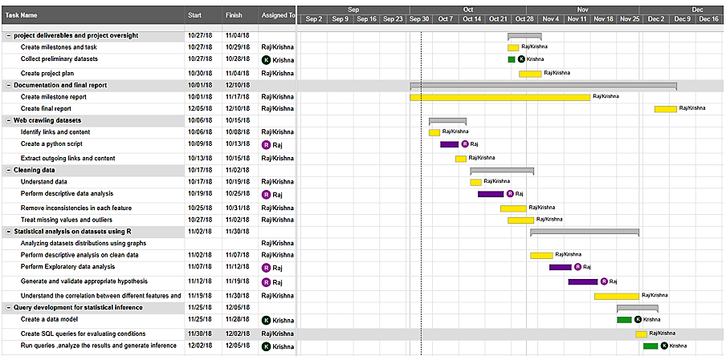

**Roles and Responsibilities:**

|  |  |  |
| --- | --- | --- |
| **Role** | **Responsibilities** | **Participant(s)** |
| Research | 1. Prepare Documentation and final project report 2. Perform Statistical Analysis on the data sets 3. Perform development of queries to identify conditional inferences using SQL. 4. Provide project deliverables and project oversight 5. Prepare deliverable status report and document milestones 6. Identify issues and resolve project barriers | Krishna Nambi |
| Research | 1. Identifying and scraping relevant data sets using Python. 2. Perform Statistical Analysis on the data sets 3. Prepare Documentation and project report 4. Review project deliverables 5. Prepare deliverable status report and document milestones | Raj Parikh |
| Mentor | 1. Provide overall project direction and guidance 2. Direct/lead team members toward project objectives | Dr David Loshin |

**References:**

* [Michelle Krasniak](https://www.socialmediaexaminer.com/author/michelle-krasniak/), 2017. YouTube Advertising: New Research and Insights for Marketers. Retrieved from: <https://www.socialmediaexaminer.com/youtube-advertising-research-insights-marketers/>. Accessed on 2nd Oct 2018.
* Jung Ung Lee, 2018. YouTube vloggers' influence on consumer luxury brand perceptions and intentions.<https://www.sciencedirect.com/science/article/pii/S0148296316304222>. Accessed on 2nd Oct 2018.
* Wilma Westenberg, 2016. The influence of YouTubers on teenagers, University of Twente. Retrieved from: <https://essay.utwente.nl/71094/1/Westenberg_MA_BMS.pdf>.
* Forbes, 2017. 5 Tips to Improve Your YouTube Marketing Strategy. https://www.forbes.com/sites/ajagrawal/2017/01/12/5-tips-to-improve-your-youtube-marketing-strategy/#40c98c56494f. Accessed on 3rd Oct 2018.